

NOVAC TECHNOLOGY SOLUTIONS

User Manual

Document Version No.: 1.00

Revision History
Version No | Reason For Changes | Author | Approver
0.01 | Draft | Vinothini S
1.00 | Reviewed & Approved the User Manual | Vinothini S | NIJANTHAN PL

Table of Contents
1. Introduction 4
2. CAR Proposal & Policy Generation 4

Introduction

The document is prepared to understand and build an application for Construction All Risks Insurance to the insured.

CAR Proposal & Policy Generation

- The Scope of CARI – Construction All Risks Insurance policy in ZIVA Application is to generate the policy by the Branch users.
- This is a core business application, which will capture the insured and construction details. The system will be used for ascertaining the premium, and generating the policy.
- The policy will be generated post capturing all the mandatory details and completing the payment.
- Post generating the Construction All Risks Insurance Policy in the NOVA Application and if the Insured request for any change in the Policy, then without making any change in the existing Policy schedule, the changes will be carried in the Endorsement Module in NOVA Application
- Without Policy numbers, Endorsement cannot be done in NOVA Application
- For each and every endorsement, Endorsement Head and Endorsement Sub Head will be configured for each product
- Each and every sub head will be mapped with the head and the user will be allowed to select only one endorsement request at a time with only one head or one sub head
- Endorsement request will be raised by the Branch user and it will be approved by the HO User
- Post Approval by the HO Users, the Endorsement schedule can be downloaded by the Branch user as well as by the HO Users

Path: Engineering -> CAR Proposal Dashboard
Screen Code: S0540

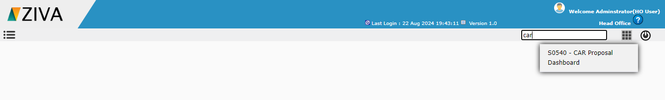

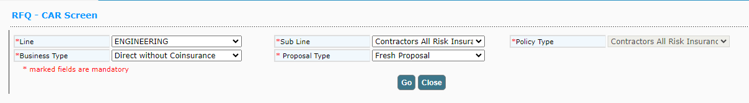
After selecting the sub Line and policy type details, on clicking Go button, remaining fields to capture the proposal details will be displayed.

In Contractor details, click on Add new Contract icon, user can able to create a new contract.
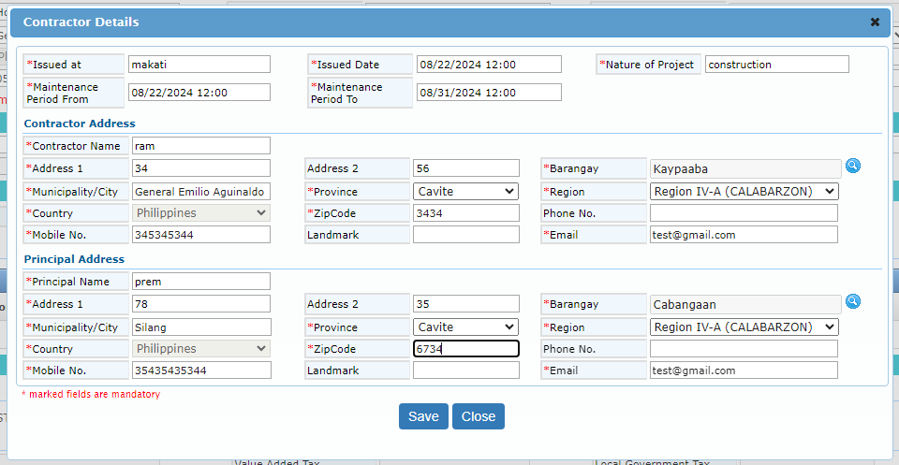
On clicking Save button, system add the contractor details. In the contractor details on clicking Sub Contractor icon, user can able to create multiple sub contractor.
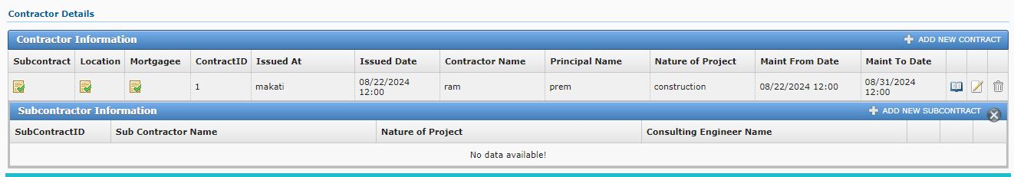
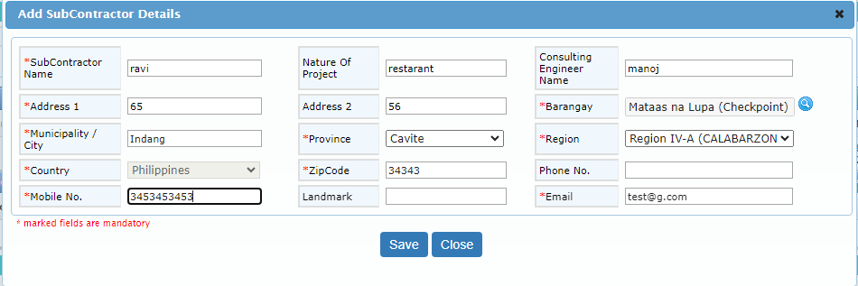

Click on Location icon to add the risk location details. Then enter the SMI and cover details for the respective location.

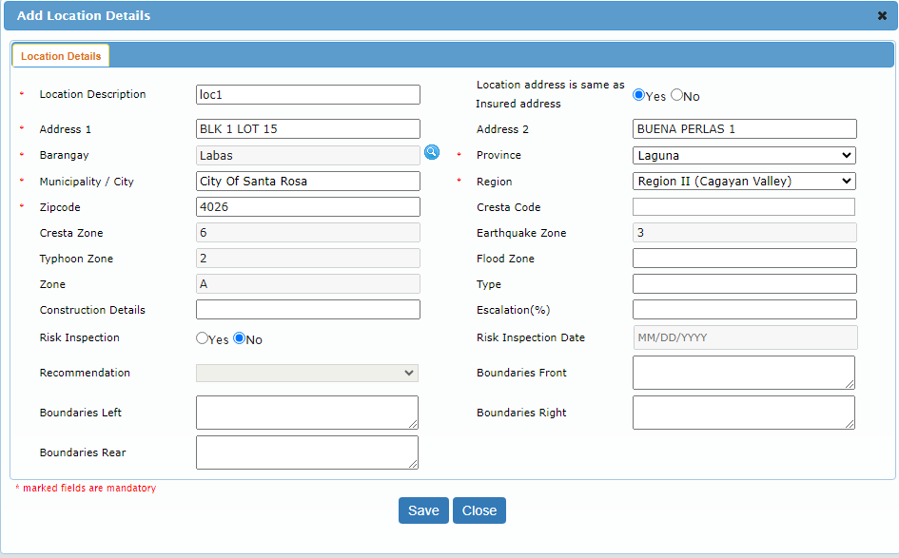

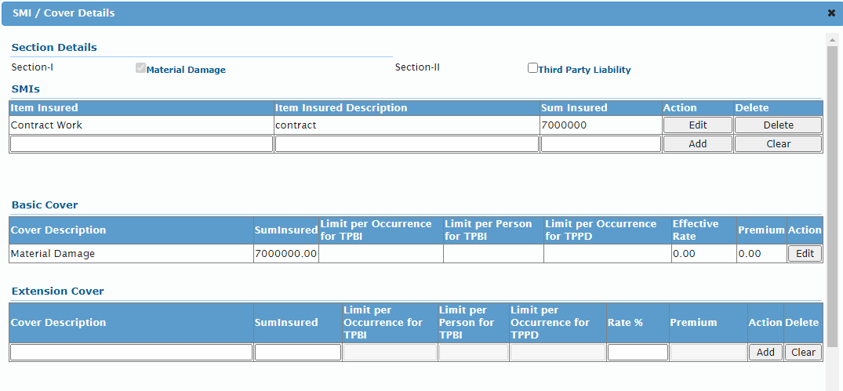
User can able to add the Mortgagee details for the location by clicking the mortgagee icon.

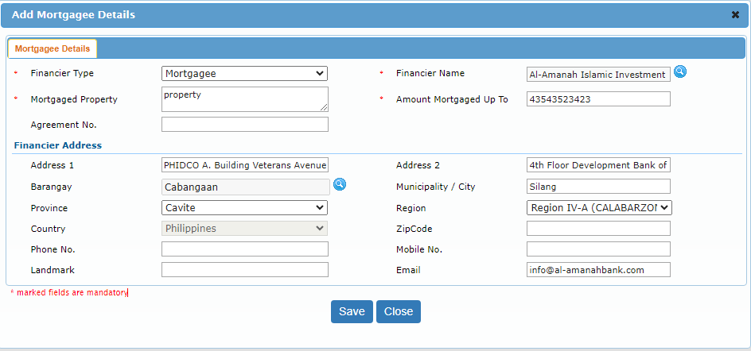

After entering all the details and click on calculate premium user can generate a Quote and then covert a proposal and generate a CAR policy.

